30-SECOND PUBLIC SERVICE ANNOUNCEMENT

Voice of Democracy

STUDENTS …
ANNOUNCER:

Need money for college? The Veterans of Foreign Wars … the VFW … gives out more than
2 million dollars in college scholarships every year to 9th … 10th … 11th and 12th grade students
through its Voice of Democracy scholarship contest. All you need to do is write and record a 3 to
5 minute audio essay on a patriotic theme. This year’s theme is “<insert current year’s theme>.” The top National prize is a $30,000 scholarship and first-place state winners receive a trip to Washington, D.C. Visit the VFW’s website at: www.vfw.org for additional information. The
student entry deadline is October 31, <insert year>.
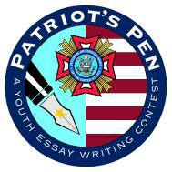

30-SECOND PUBLIC SERVICE ANNOUNCEMENT
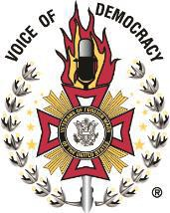

Patriot’s Pen

STUDENTS ….
ANNOUNCER:

Would you like to win money for college? The Veterans of Foreign Wars … the VFW … gives out over 1 million dollars in awards every year to 6th, 7th and 8th grade middle school students through its Patriot’s Pen essay contest. All you need to do is write a 300 to 400 word essay on a patriotic theme. This year’s theme is “<insert current year’s theme>.” The top National prize is
$5,000. Visit the VFW’s website at: www.vfw.org for additional information. The student entry deadline is October 31, <insert year>.

